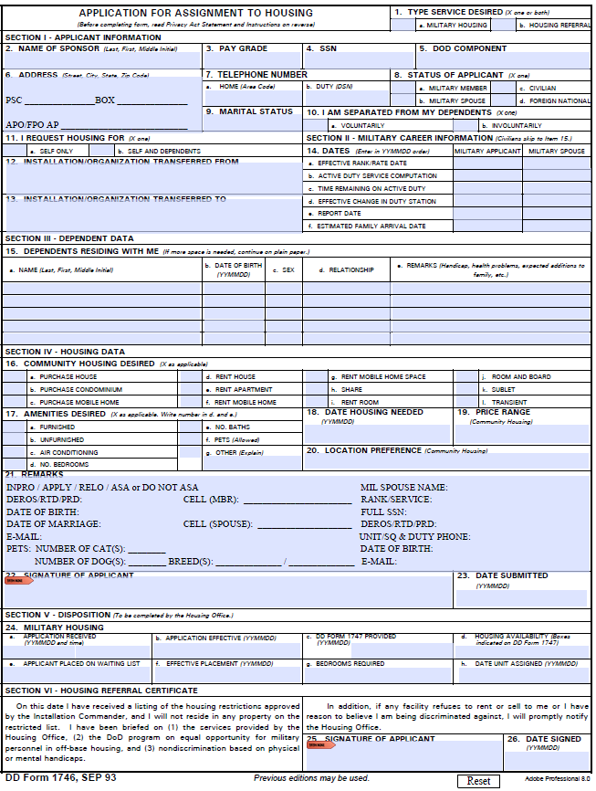
ANNOTATE LODGING INFO AT TOP OF APPLICATION
- A. MIL HOUSING
- MIL MBR NAME (SPONSOR) IF MIL TO MIL WHOM EVER HAS THE CHILDREN UNDER THEM/IF NO CHILDREN HIGHER RANKING MBR
- PAY GRADE OF SPONSOR
- FULL SOCIAL/DOD ID
- BRANCH OF SERVICE
- PSC BOX ADDRESS (LV BLANK IF PSC BOX HASN’T BEEN ASSIGNED)

  - LOCAL PHONE NUMBER ONLY
  - LOCAL DSN

  - SELECT IF MIL TO CIV
  - SELECT IF DUAL MIL (SEL a. AS WELL)
- MARITAL STATUS
- AF ONLY (IF COMING FROM A OCONUS LOCATION)
- SELF AND DEPENDENTS
- UNIT NAME AND BASE COMING FROM
- UNIT NAME AND BASE ASSIGNED
- DATES MUST BE FILL IN FULL
  - EFF DATE OF CUR RANK
  - DATE ENTERED SERVICE
  - END OF ELISTMENT/OFFICERS LEAVE BLANK OR N/A
  - DATE CHECKED OUT OF LAST DUTY STATION
  - DATE YOU ARRIVED IN OKI
  - DATE FAM ARRIVED IN OKI/WILL ARRIVE (NEED FLT ITEN)
- ALL COMMAND SPONSORED/MED CLEARED DEPENDENTS
  - NAME
  - CHILDRENS AGE
  - BIRTH DAY
  - SEX
  - RELATIONSHIP
  - REMARKS (PREG/EFMP)
- LEAVE BLANK
- INITIAL (STICKER ADDED FOR TLA ACKNOWLEDGMENT)
- LEAVE BLANK
- LEAVE BLANK
- LEAVE BLANK
- INDICATE THE FOLLOWING
  - CIRCLE INPRO
  - ASA (ALLOWING SPOUSE TO ACCEPT HOUSE)
  - DEROS=ROTATION DATE/PRD
  - FULL DATE OF BIRTH (MBR)
  - FULL DATE OF MARRIAGE (MBR)
  - PERSONAL/SPOUSE/DUTY EMAIL
  - NUMBER OF PETS/DOGS MUST PROVIDE BREED
  - LOCAL CELL NUMBERS/CAN PROVIDE SPONSORS IF NEEDED
IF MIL TO MIL SPOUSE INFO ADDED AS WELL

- SPONSOR SIGN (DIGITALLY SIGN)
- FULL DATE
- COUNSELOR WILL FILL IN A-H
- LEAVE BLANK
- LEAVE BLANK

